Skillage App

TEST PLAN
12/03/2018

12/03/2018
This document contain 10 pages
[Category]

Document review and approval
Revision history
This document has been reviewed by
 | Reviewer | Date reviewed
This document has been approved by
 | Subject matter experts
 | Name | Signature | Date reviewed

Contents
1 Introduction 1
1.1 Purpose 1
1.2 Scope 1
2 Test Item(s) 1
2.1 Project description 1
2.2 Items to be Tested 2
2.3 Items Not to be tested 2
2.4 Test Approach(s) 2
2.5 Test Entry and SIT/ UAT Exit Criteria 4
2.5.1 Test Entry 4
2.5.2 SIT Phase 5
2.5.3 UAT Phase 5
2.6 Test Deliverables 5
2.7 Test Suspension / Resumption Criteria 5
2.7.1 Suspension 5
2.7.2 Resumption 6
3 Risk and mitigation 6
3.1 Test Risks / Issues 6
4 Test Environment 6
4.1 Test Environment URL 6
4.2 Test Hardware(s) 6
4.3 Test Data 6
4.4 Bugs Severity and Priority Definition 7
4.5 Tools, Techniques, and Methodologies 7
4.6 SIT Test Report Matrix (Example format) 8
4.7 UAT Test Report Matrix (Example format) 8
5 Team and Role 8
6 Test Milestones and Schedule 9

Introduction

Purpose
The purpose of this Test Plan is gather all the information necessary to plan and control the test effort for testing the Skillage App. It describes the appropriate strategies, process, workflows and methodologies used to plan, organize, execute and manage testing of project.

Scope
The scope of this testing effort includes a summary of what will and will not be tested. Below is the list of in scope testing types:
- Functionality
- Data & Transaction
- System Administration.
- Maintainability
- Compatibility
Here is the list of out of scope testing types:
- Security ( VAPT )
- Localization (multiple languages, zip codes)
- Documentation and Packaging
- Content (grammar)
- Date & Time handling
- Error & Disaster handling & recovery
- Installation, Setup & Initial Configuration
- Load Balancing
- Networking
- Usability

Test Item(s)

Project description
- [Bổ sung].

Items to be Tested
Module(s) | Feature(s) | Priority
Win Application | Load Data | High
Win Application | Edit Data | High
Web API | Load Data | High
Web App | Load Data | High

Items Not to be tested
Module(s) | Feature(s) | Comments
Win Application | Add data

Test Approach(s)

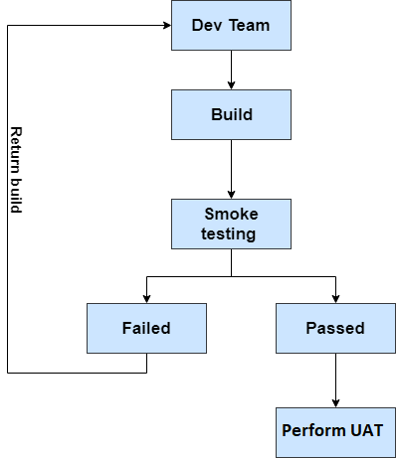

- Smoke testing is performed based on the highest priority test cases in the test case list.
- UAT (User Acceptance Testing) is performed rely on the rest of test cases in the list after smoke testing
- If almost the priority of bugs found out during testing procedure are high and highest, QC team will consider whether to do smoke testing for the build fixed bugs or not.
Test Types | Test Name
Functional | GUI Testing
Functional | Functional Testing
Functional | Component Testing
Functional | System Integration Testing (SIT)
Functional | Smoke Test
Functional | Regression Test
Functional | Scenario Testing
Functional | User Acceptance Test (UAT)
Non-Functional | Compatibility Testing (Web view, Mobile view)
Non-Functional | Maintainability Testing
Non-Functional | Performance Test ( on development site )

GUI TESTING
- GUI testing is the process of testing the system's Graphical User Interface of the Application under Test. GUI testing involves checking the screens with the controls like menus, buttons, icons, and all types of bars - toolbar, menu bar, dialog boxes and windows, etc.

Functionality Testing will be done within each Phase.

- Ensure that the functions behaves or performs in accordance to the functional or requirement specifications
- Ensure that related components are setup, tested and available for the functional test to be carried out
- Ensure that test cases including positive and negative scenarios; as well as, time sensitive test cases such as cross over year, leap year and business calendar

COMPONENT TESTING
- Component testing is a method where testing of each component in an application is done separately.

SYSTEM INTEGRATION TEST will be done within each Phase.
- Ensure that all requirements/ functionalities, performance, stability and resilience of the all components in the System have been thoroughly tested and met
- Cover functional, interfacing and integration tests on all units/ modules developed
- Conduct the SIT on the System in the testing and production environments to ensure that the software and hardware have been installed and setup properly.

SMOKE TEST
- Smoke Test will be executed when on complex changes or multiple component changes, build releases. The purpose is saving time in: fixing and wasted larger test level executions.

REGRESSION TEST
- At the completion of acceptance tests for each release, manual run the regression test suite to ensure that subsequent modifications to the system do not introduce regressions.

SCENARIO TESTING
- Ensuring that the interfacing systems are able to correctly handle and respond to both normal and exceptional file exchange/processing scenarios.

USER ACCEPTANCE TESTS: Customer to perform the current process manually. If the following outcomes are achieved during the allocated UAT period, it is assumed the UAT would be considered passed.
- Skillage Winapp, Skillage Webapp in accordance to the Functional Specifications Design and UI/UX design
- APIs in accordance to Design Specifications Design

There will be at least 14 days of time allocated for UAT. Upon passing of UAT, the application will be moved to production and Customer will need to do another round of verifications to ensure results are consistent in production environment –VAPT (2nd Round)

During this period Customer will need to allocate 50% of their time to support and conduct the testing.

COMPATIBILITY TESTING
- Verify if applications work on Browser Standards: Safari, Firefox, Chrome, Edge and Internet Explorer (with latest version at the testing time).
- Verify applications work on mobile browser, explicitly responsive mobile design.

MAINTAINABILITY TESTING
- Verify if the system is in maintenance mode, which procedures system will do to prevent user actions on the system to restrict any error.

PERFORMANCE TESTING
- Load testing - checks the application's ability to perform under anticipated user loads. The objective is to identify performance bottlenecks before the software application goes live.
- Stress testing - involves testing an application under extreme workloads to see how it handles high traffic or data processing. The objective is to identify breaking point of an application.
Note: Performance test will be execute on development site only.

Test Entry and SIT/ UAT Exit Criteria

Test Entry
- 1 The system has passed the exit criteria of previous stage (if applicable)
- Completed test log and acceptance of previous test stage
- Completed updates (if any) to technical documents to reflect changes from past tests
- Test Plan and Test Scenarios reviewed and approved
- Test environment (including external interfaces) available and stable i.e. system parameters, static data and connectivity setup completed
- Test data setup completed and available

SIT Phase
Defect Type | Exit from SIT  (Open defects allowed) | Test case execution Coverage in SIT | Test Case Pass Rate in SIT
Critical | 0 | 100% | 100%
Major | < 0 | 100% | 100%
Minor | <5 | 100% | 95%
Cosmetic | <20 | 100% | 95%

UAT Phase
Defect Type | Exit from UAT (Open defects allowed) | Test case execution Coverage in UAT | Test Case Pass Rate in UAT
Critical | 0 | 100% | 100%
Major | 0 | 100% | 100%
Minor | <5 | 100% | 100%
Cosmetic | <20 | 100% | 95%

Test Deliverables
These documents should be provided by Skillage App:
- Test plan
- Test schedule
- Test Requirement Traceability Matrix
- Test case
- Test Report

Test Suspension / Resumption Criteria

Suspension
- 1 Significant variations to requirements in more than 30% of the completed test scenarios
- Test environment issues that prevent testing to be conducted effectively (e.g. slow system performance, unstable system uptime, unavailability of test data)
- Unavailability of testing resources to complete the testing on schedule
- (testers, hardware or software)
- More than 50% of the defects in the completed test scenarios are ‘High’ or ‘Medium’ severity

Resumption
If testing is suspended, resumption will only occur when the problem(s) that caused the suspension has been resolved.

Risk and mitigation

Test Risks / Issues
Feature(s) | Comments

Test Environment

Test Environment
Environment | URL/ Account
Skillage Windows Application | TBD
Skillage Web API | TBD
Skillage WebApp | TBD

Test Hardware(s)
Hardware Name | Version
Mobile Device with iOS | Latest version of iOS ( iPhone 7+)
Mobile Device with Android | Android version 8.1
PC | Windows 10
Internet connection | Line connect/ Wifi/ 4G

Test Data
Module require Test Data | Data

Bugs Severity and Priority Definition
The defect severity rating is used to assign a severity rating to a defect based on the impact of the defect on the functioning of the product or service. In order to ensure that all teams have a consistent approach to defects and issues the severities in the following table will be used.

Severity ID | Severity Level | Severity Description
1 | 1 – Critical  Priority: High | No further testing is possible until this defect is fixed. Testers cannot continue working.  Defect must be addressed immediately.  Defect will delay testing and impact time frames.
2 | 2 – Major  Priority: High | Defect has a significant impact on testing and should be fixed before the next release if possible.  Defect has broken an interface, no further testing on that interface can continue.  Defect has major impact but workaround exists.  May impact testing time frames.
3 | 3 – Minor  Priority: Medium | Defect affects component but does not stop testing of that interface.  Defect should be addressed in the next release; delivery should be negotiated around impact to testing.
4 | 4 – Cosmetic  Priority: Low | The defect is purely cosmetic and has no effect on testing interface; minimal regression testing is required.  Defect to be addressed when possible.

Tools, Techniques, and Methodologies
Tools/ Techniques/ Methodologies | When/ How it used
Jira | For keep track the defects comes from the project
Microsoft Office (Word, Excel) | For editing/ reviewing the documents
Invision app | For prototype, design for the application UI
JMeter | For Performance Test
Postman | For API Testing
Browsers | IE 11/ Chrome/ Firefox/ Safari latest version.
Database permission | For database testing/ Data mapping
Audit log permission | For testing audit log activities

SIT Test Report Matrix (Example format)
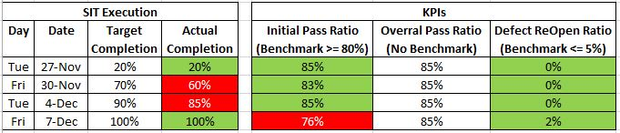

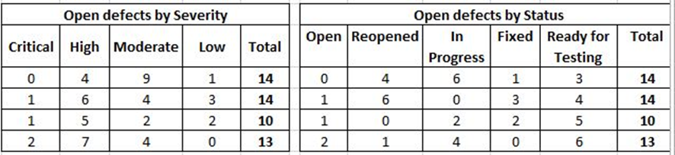

UAT Test Report Matrix (Example format)

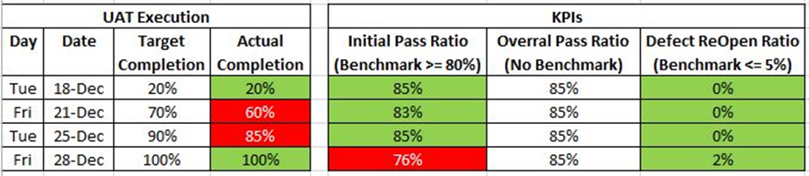
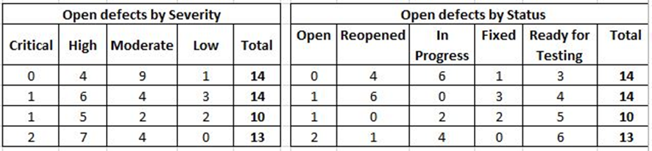

Team and Role
Name | Role

Test Milestones and Schedule

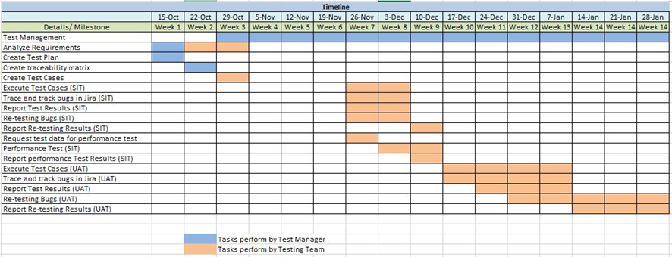

Appendix A: References
The following table summarizes the documents referenced in this document.

Document Name and Version | Description | Location
SkillApp-TestCase - v1.0 - Test execution | SkillApp TestCase

Appendix B: Key Terms
The following table provides definitions for terms relevant to this document.
Term | Definition

